WEEK 1
Programme 1 - Design a simple static HTML web page using:
- Ordered lists
- Unordered lists
- Tables
Display and maintain student record information in a structured format.
CODE:
<!DOCTYPE html>
<html lang="en">
<head>
<meta charset="UTF-8">
<title>Student Record System</title>
<style>
body { font-family: Arial, sans-serif; background-color: #f0f8ff; padding: 20px; }
h1 { color: #2c3e50; text-align: center; }
.container { background: white; padding: 20px; border-radius: 10px; box-shadow: 0 0 10px rgba(0,0,0,0.1); }
table { width: 100%; border-collapse: collapse; margin-top: 20px; }
th, td { border: 2px solid #3498db; padding: 12px; text-align: left; }
th { background-color: #3498db; color: white; }
tr:nth-child(even) { background-color: #ecf0f1; }
ul, ol { line-height: 1.6; color: #34495e; }
</style>
</head>
<body>
<div class="container">
<h1>Student Information Portal</h1>
<h3>General Details (Unordered List)</h3>
<ul>
<li><strong>Name:</strong> John Doe</li>
<li><strong>Department:</strong> Computer Science</li>

<li><strong>Year:</strong> 3rd Year</li>
<li><strong>Section:</strong> A</li>
</ul>
<h3>Registration Process (Ordered List)</h3>
<ol>
<li>Login to the portal using Student ID.</li>
<li>Select the current Semester (Semester V).</li>
<li>Choose elective courses from the sequence.</li>
<li>Click 'Submit' to finalize registration.</li>
</ol>

<h3>Student Records Table</h3>
<table>
<thead>
<tr>
<th>Roll No</th>
<th>Name</th>
<th>Department</th>
<th>GPA</th>
</tr>
</thead>
<tbody>
<tr>
<td>101</td>
<td>Alice Smith</td>
<td>CSE</td>
<td>9.2</td>
</tr>
<tr>
<td>102</td>
<td>Bob Johnson</td>
<td>ECE</td>
<td>8.5</td>
</tr>
</tbody>
</table>
</div>
</body>
</html>
OUTPUT: 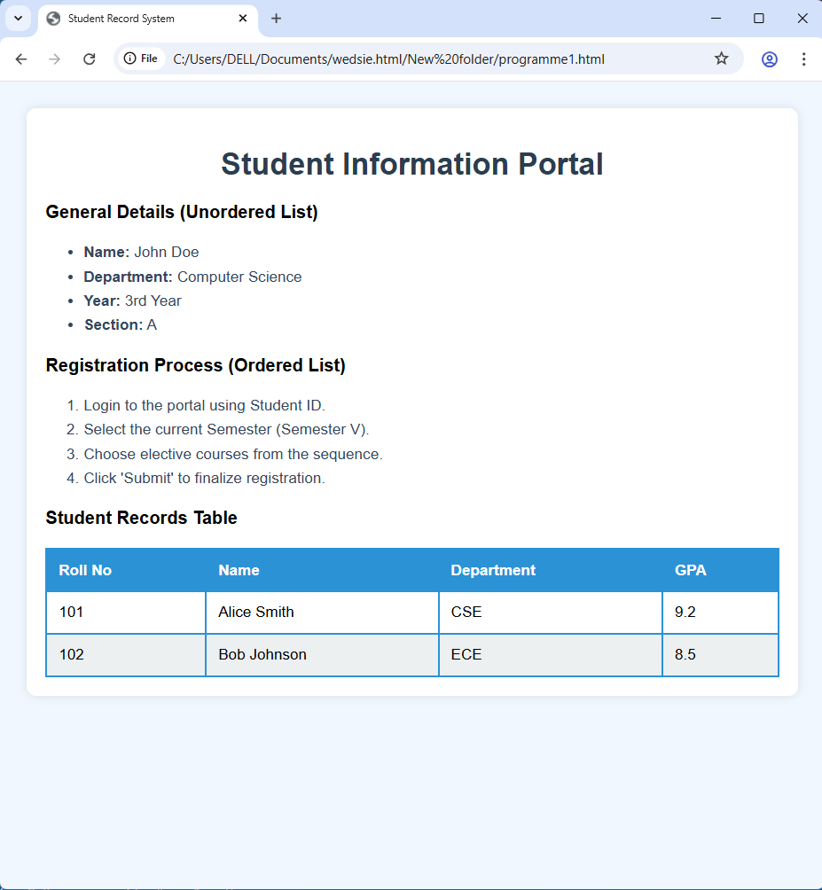

Programme 2 - Design static web pages for an online book store website:
- Home Page: Static home page with three frames
- Login Page
- Catalogue Page: Display all available books in a table
- Registration Page
CODE and OUTPUT:
<!DOCTYPE html>
<html>
<head>
<title>Online Book Store</title>
</head>
<frameset rows="20%, 80%">
<frame src="header.html" name="header">
<frameset cols="25%, 75%">
<frame src="nav.html" name="navigation">
<frame src="catalogue.html" name="content">
</frameset>
</frameset>
</html>
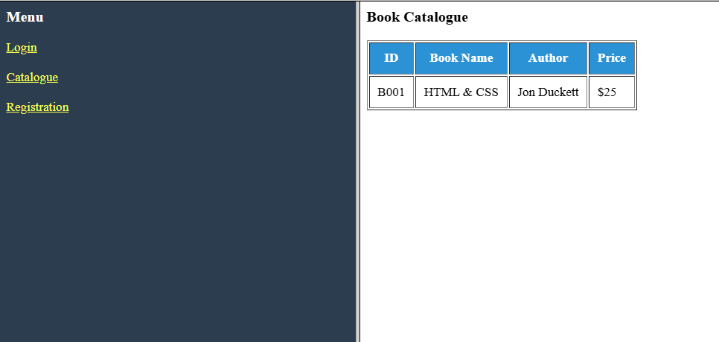
<body style="background-color: #2c3e50; color: white;">
<h3>Menu</h3>
<a href="login.html" target="content" style="color: yellow;">Login</a><br><br>
<a href="catalogue.html" target="content" style="color: yellow;">Catalogue</a><br><br>
<a href="register.html" target="content" style="color: yellow;">Registration</a>
</body>
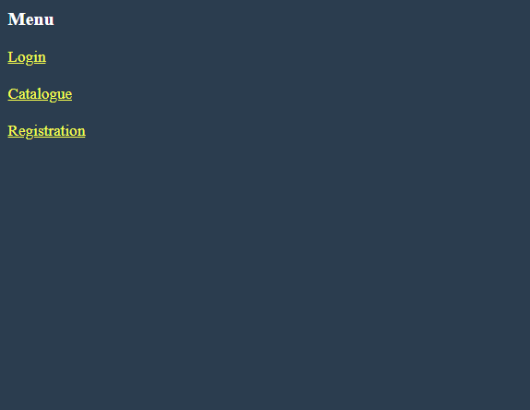
<h3>Book Catalogue</h3>
<table border="1" cellpadding="10">
<tr bgcolor="#3498db" style="color:white">
<th>ID</th>
<th>Book Name</th>
<th>Author</th>
<th>Price</th>
</tr>
<tr>
<td>B001</td>
<td>HTML & CSS</td>
<td>Jon Duckett</td>
<td>$25</td>
</tr>
</table>
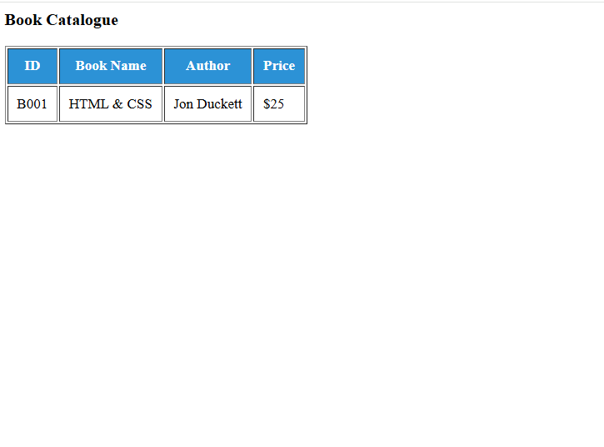
Programme 3 - Design an HTML web page using anchor (<a>) tags and an iframe to display
linked content within the same page.
The iframe should load a web page containing an image using the <img> tag
CODE:
<!DOCTYPE html>
<html>
<head>
<title>Iframe Gallery</title>
</head>
<body style="text-align: center; font-family: sans-serif;">
<h1>Iframe Display System</h1>
<a href="imagepage.html" target="myIframe" style="padding: 10px; background: #e74c3c; color: white; text-decoration: none; border-radius: 5px;">
Load Image Page
</a>
<br><br>
<iframe name="myIframe" width="80%" height="400px" style="border: 2px dashed #7f8c8d;"></iframe>
</body>
</html>
<html>
<body style="display: flex; justify-content: center; align-items: center; height: 100vh;">
<img src="https://via.placeholder.com/300" alt="Sample Student Image" width="300" height="300">
</body>
</html>
OUTPUT:

Programme 4 - Create a web page using HTML that contains a form to collect student
information including:
- Name
- Email
- Branch
- Gender
- Address
CODE:
<!DOCTYPE html>
<html>
<head>
<title>Student Registration Form</title>
<style>
form { width: 350px; margin: auto; border: 1px solid #ccc; padding: 20px; border-radius: 10px; background: #fafafa; }
div { margin-bottom: 15px; }
label { display: block; font-weight: bold; }
input[type="text"], input[type="email"], select, textarea { width: 100%; padding: 8px; box-sizing: border-box; }
</style>
</head>
<body>
<h2 style="text-align: center;">Student Information Form</h2>
<form action="submit.html" method="POST" id="studentForm">
<div>
<label>Name:</label>
<input type="text" name="student_name" placeholder="Enter your name" required>
</div>
<div>
<label>Email:</label>
<input type="email" name="email" placeholder="Enter your email" required>
</div>
<div>
<label>Branch:</label>
<select name="branch" required>
<option value="">--Select Branch--</option>
<option value="CSE">CSE</option>
<option value="ECE">ECE</option>
<option value="EEE">EEE</option>
</select>
</div>
<div>
<label>Gender:</label>
<input type="radio" name="gender" value="Male" required> Male
<input type="radio" name="gender" value="Female"> Female
</div>
<div>
<label>Address:</label>
<textarea name="address" rows="4" placeholder="Enter your address" required></textarea>
</div>
<input type="submit" value="Submit">
<input type="reset" value="Reset">
</form>
</body>
</html>
OUTPUT:
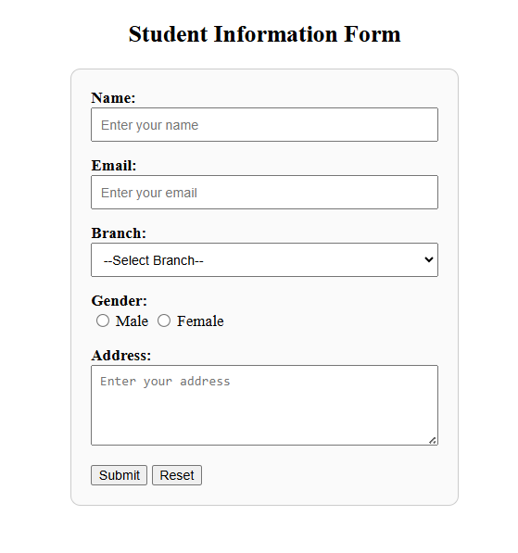
Programme 5 - Create a web page to embed a map along with:
- Hot spots
- Frames
- Links
CODE:
<!DOCTYPE html>
<html>
<body>
<h2>Click on the Regions of the Map</h2>
<img src="https://via.placeholder.com/600x400/34495e/ffffff?text=Interactive+Map"
usemap="#workmap" width="600" height="400">

<map name="workmap">
<area shape="rect" coords="34,44,270,350" alt="Region A" href="content.html?region=A" target="content">
<area shape="circle" coords="450,200,80" alt="Region B" href="content.html?region=B" target="content">
</map>

<p>Clicking the shapes above will load details in the content frame.</p>
</body>
</html>
OUTPUT:
